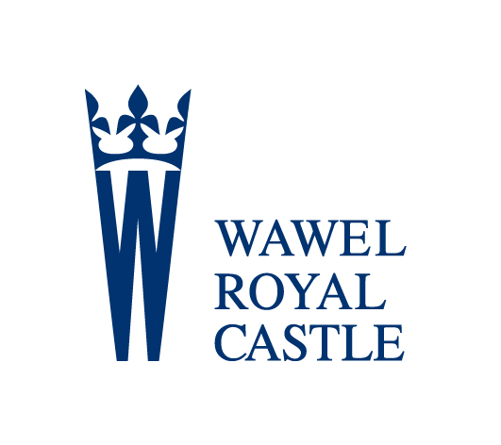
Wawel Royal Castle

RESERVATION FORM *

Date of visit:
Starting time of visit:
Number of persons:

Chosen Exhibitions:
- State Rooms
- Royal Private Apartments
- Crown Treasury and Armoury
- Royal Gardens
- Sandomierska Tower
- Dragon’s Den

Other ………………………………………………………….............................................…………

Guide – preferred language
Name and last name
of the Organiser
Company name
 | Phone number | Fax number
e-mail address
- Reservation Form should be e-mailed (at the latest) 14 days prior to the visit: bot@wawel.org.pl or by fax: (+ 48 12) 422.64.64
You will receive confirmation no later than 3 days before the date of your visit.

